#include <stdio.h>

#include <stdlib.h>

main() {

// 5 numbers for entry, Lvalue for lowest value, Hvalue for highest value, count for average and entries entered

int choice = 0, count = 0, input = 0, number1 = 0, number2 = 0, number3 = 0, number4 = 0, number5 = 0, Lvalue = 0, Hvalue = 0, result = 0;

// specifies the value for the variable - average

double average = 0;

do

{

// Select 5 numbers

printf("Select the values:\n");

scanf_s("%i", &number1);

// Count adds per entry

count++;

scanf_s("%i", &number2);

count++;

scanf_s("%i", &number3);

count++;

scanf_s("%i", &number4);

count++;

scanf_s("%i", &number5);

count++;

// Menu

printf("Select the option below:\n");

printf("1. Display the smallest number entered.\n");

printf("2. Display the largest number entered.\n");

printf("3. Display the sum of the five numbers entered.\n");

printf("4. Display the average of the five numbers entered.\n");

printf("5. Exit.\n");

scanf_s("%i", &choice);

switch (choice)

{

// Lowest

case 1:

// Give Lvalue a value that is lower than all the numbers

Lvalue = number1;

if (Lvalue > number2) {

Lvalue = number2;

}

if (Lvalue > number3) {

Lvalue = number3;

}

if (Lvalue > number4) {

Lvalue = number4;

}

if (Lvalue > number5) {

Lvalue = number5;

}

printf("The smallest number entered is: %i \n", Lvalue);

// Reset values

Lvalue = 0;

result = 0;

count = 0;

break;

// Highest

case 2:

// Allow all values to compete for highest value

if (number1 > Hvalue) {

Hvalue = number1;

}

if (number2 > Hvalue) {

Hvalue = number2;

}

if (number3 > Hvalue) {

Hvalue = number3;

}

if (number4 > Hvalue) {

Hvalue = number4;

}

if (number5 > Hvalue) {

Hvalue = number5;

}

printf("The largest number entered is: %i \n", Hvalue);

// Reset values

Hvalue = 0;

result = 0;

count = 0;

break;

// Sum

case 3:

result = (number1 + number2 + number3 + number4 + number5);

printf("The sum of the five numbers entered is: %i \n", result);

// Reset values

count = 0;

result = 0;

break;

// Average

case 4:

result = (number1 + number2 + number3 + number4 + number5);

average = (double)result / count;

printf("The average of the five numbers entered is: %.2lf \n", average);

// Reset values

average = 0;

count = 0;

result = 0;

break;

case 5:

break;

default:

printf("That is an invalid option.\n\n");

break;

}

// Exit

} while (choice != 5);

}

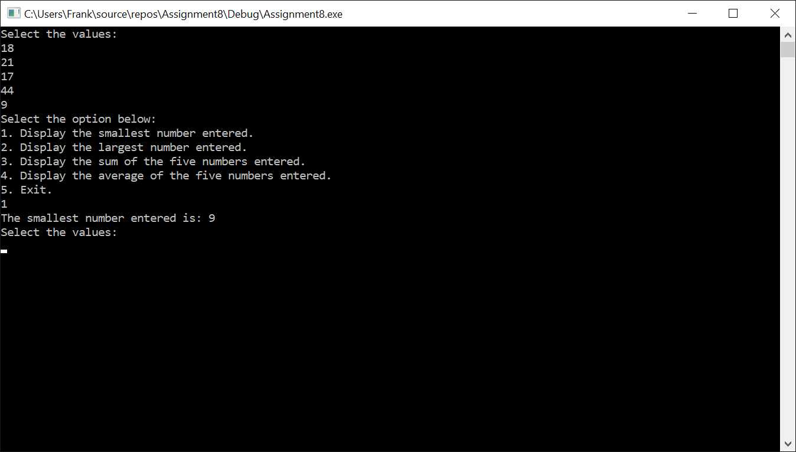

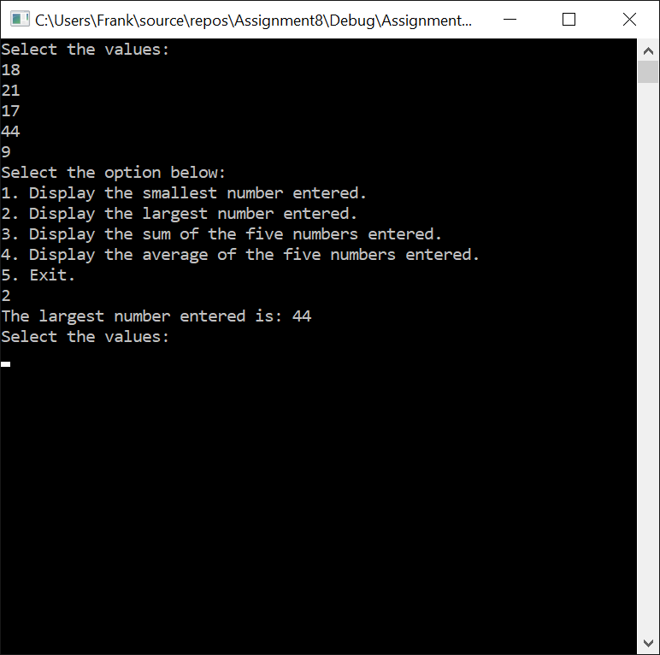

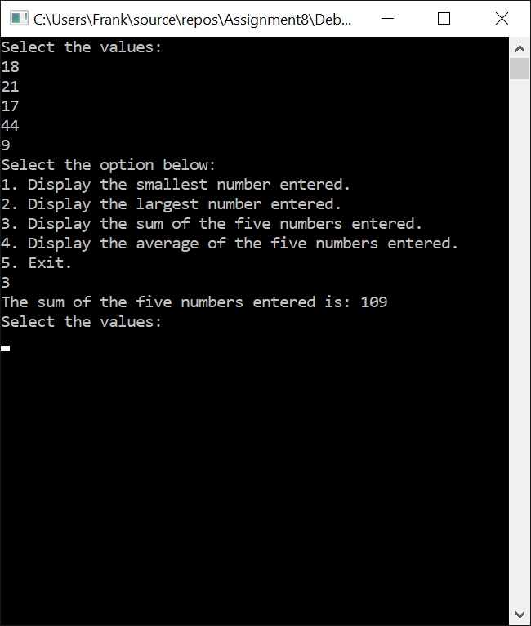

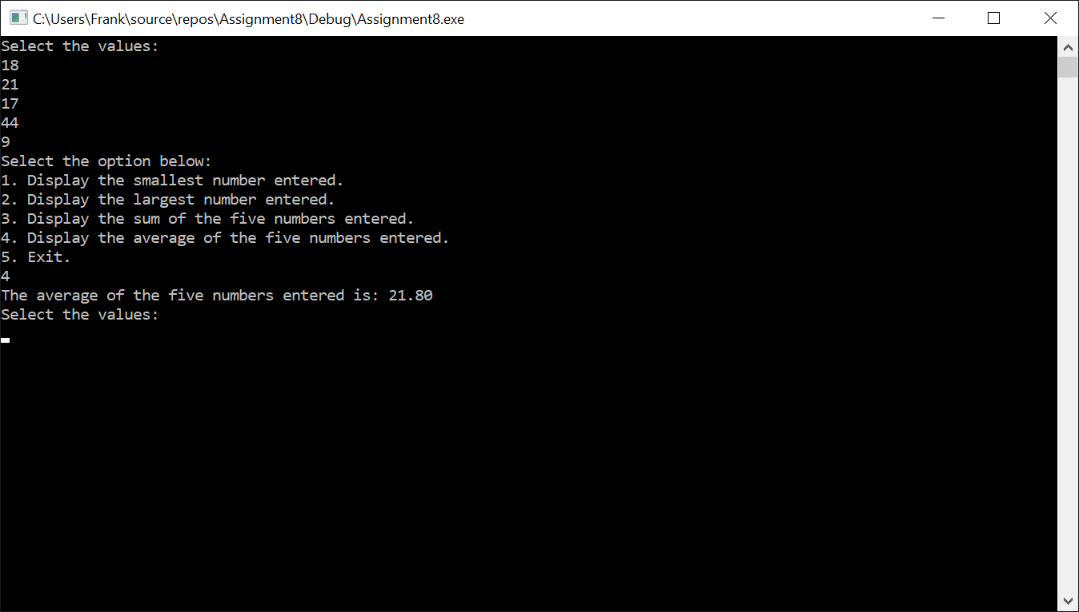

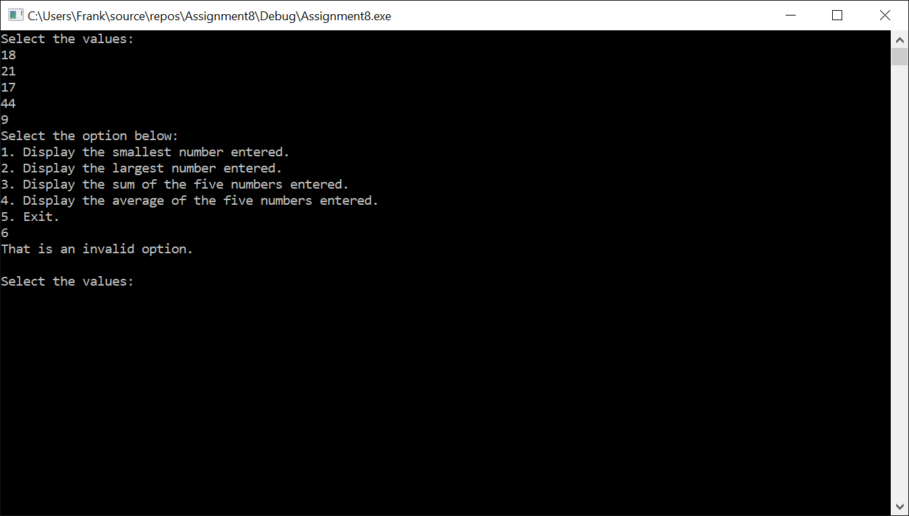

**Assignment 8 – Programming**

We want to choose 4 options with the 5 values entered into this program. The 4 options let’s us find the lowest value, highest value, total sum of all values or the average of all the 5 values entered in the program.

**IPO**

|  |  |  |
| --- | --- | --- |
| **Input**  Choice, count, input, number1, number2, number3, number4, number5, Lvalue, Hvalue, result, (double) average | **Processing**  Enter **5 values** for **number1, number2, number3, number4, number5**  Print Menu, 5 options   1. Display Smallest Value 2. Display Largest Value 3. Display sum of all values 4. Display the average of all values, 5. Exit   **Choice** creates case (condition)   1. Print Smallest Value 2. Print Largest Value 3. Print Sum of all values 4. Print average of all values   Reset values. | **Output**  Output the sum or smallest value or largest value or average of all values. |

**Test Case**

|  |  |  |
| --- | --- | --- |
| Input | Choice | Result |
| 18, 21, 17, 44, 9 | 1 | Lowest Number - 9 |
| 18, 21, 17, 44, 9 | 2 | Highest Number - 44 |
| 18, 21, 17, 44, 9 | 3 | Total Sum - 109 |
| 18, 21, 17, 44, 9 | 4 | Average – 21.80 |
| 18, 21, 17, 44, 9 | 6 | That is an invalid option. |